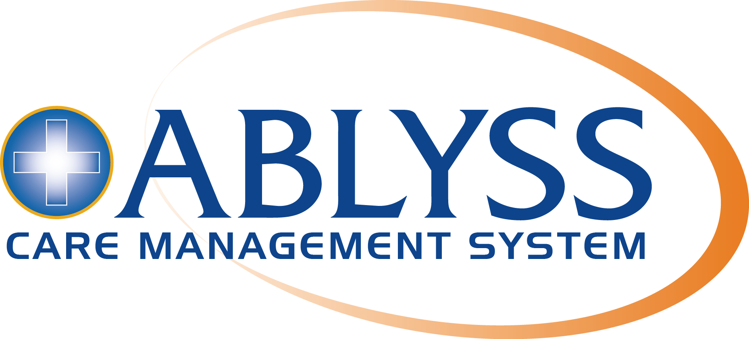 | 5 The Courtyard,  2 Finney Lane,  Heald Green  Cheshire,  SK8 3GZ

Tuesday, March 31, 2020

To whom it may concern
Subject: Coronavirus (COVID-19) Confirmation of Key Worker / Essential activity Status
Employee: [INSERT EMPLOYEE NAME]
[INSERT COMPANY NAME] has provided this letter to our employee because they work for a residential care home providing essential social care and support services to older, disabled or other vulnerable people. This means that as part of their role, they are likely to have to travel to and from work or provide shopping for the older or disabled people they care for.

The government has confirmed that social care is an essential partner to the National Health Service (NHS) in combatting COVID-19. The bearer of this letter should therefore be regarded as a key worker, whose role is essential for the UK’s response to COVID 19, in line with Government statements. This is because they are:

- A member of the front-line social care workforce, or
- A volunteer undertaking similar work; or
- A member of staff whose role is essential in supporting front-line social care workers to undertake their role.

Our staff usually carry an identity card or badge with them, and you may ask the bearer of this letter to produce their badge to confirm their identity. However, there are circumstances where staff may not have been issued with an identity badge, or they may not have it with them today. In which case, you may verify their identity by telephoning [insert telephone number]

In making this request, we recognise that we are asking you to place your trust in us and our workforce. We have asked everyone who has received this letter to use it responsibly and not to share it with anyone else.

Anything you can do to support members of the social care workforce during COVID-19 is truly appreciated.

Yours faithfully,
[INSERT NAME]
[INSERT JOB TITLE]

